aTable 1: Variable Definitions and Sources
Category | Variable | Definition & Transformation | Data Source
Target | Sale Price | Transaction price of residential property (£) - Log-transformed for modelling | UK Price Paid Data (PPD)
Climate Exposure | Elevation (m) | Mean ground elevation at property location – Raw (meters) | Ordinance Survey Open Data – OS Terrain 5
 | Distance to River (m) | Euclidean distance to nearest tidal frontage - Raw (meters). Log transformed for modelling | Ordinance Survey Open Data – OS Terrain 5
 | Flood Zone 3 (High Risk) | Binary indicator: 1 if within Flood Zone 3 (>1% annual probability), 0 otherwise. | Environment Agency Flood Map
 | Flood Zone 2 (Moderate Risk) | Binary indicator: 1 if within Flood Zone 2, 0 otherwise. | Environment Agency Flood Map
Adaptive Capacity | EPC Rating | Energy efficiency score | EPC Register
 | PMU | Spatial indicator for location within a TE2100 Policy Management Unit. | TE2100 Plan
Structural | Total Floor Area | Total internal floor area (sqm) | EPC Register
 | Number of Habitable Rooms |  | EPC Register
 | Property Type | Categorical: House, Flat, Maisonette, Bungalow | EPC Register

Table 2. Model performance in predicting residential sale prices in the Thames Estuary
Model | RMSE (GBP) | MAE (GBP) | R² (test)
Hedonic OLS | 0.310 | 0.180 | 0.658
Elastic Net | 0.319 | 0.183 | 0.644
Random Forest | 0.0.273 | 0.140 | 0.734
XGBoost | 0.268 | 0.139 | 0.743

Table 2 compares predictive performance across linear and non-linear models. The machine learning models substantially outperform the traditional hedonic specification.
- OLS and Elastic Net show identical performance (R² = 0.658), indicating limited benefit from penalization under current feature specification.
- Random Forest improves explanatory power (R² = 0.734).
- XGBoost performs best (R² = 0.743), reducing RMSE by approximately 15% relative to OLS.
This confirms that:
Climate-risk pricing in the Thames Estuary is nonlinear and interaction-driven, which linear models fail to fully capture.
The improvement from 0.658 to 0.743 represents a 15.5% gain in explained variance, economically meaningful for property valuation models.

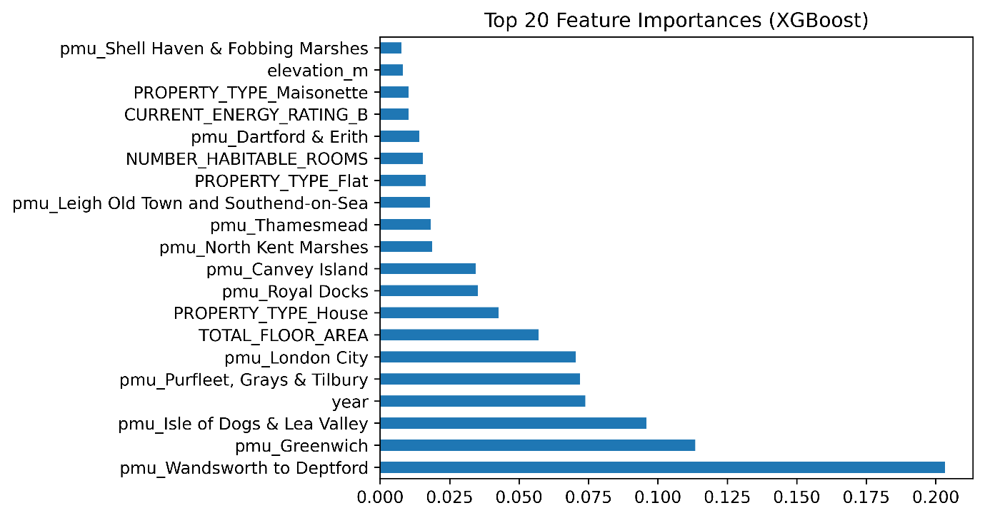
Figure 1: Top 20 Feature Importance Variables
While structural attributes like TOTAL_FLOOR_AREA remain dominant, climate and adaptation drivers such as elevation, distance to river, and TE2100 policy units (pmu) emerge as top predictors. Specifically, location in the Wandsworth to Deptford and Greenwich policy units carries significant predictive weight, highlighting the capitalization of defense infrastructure into private values.

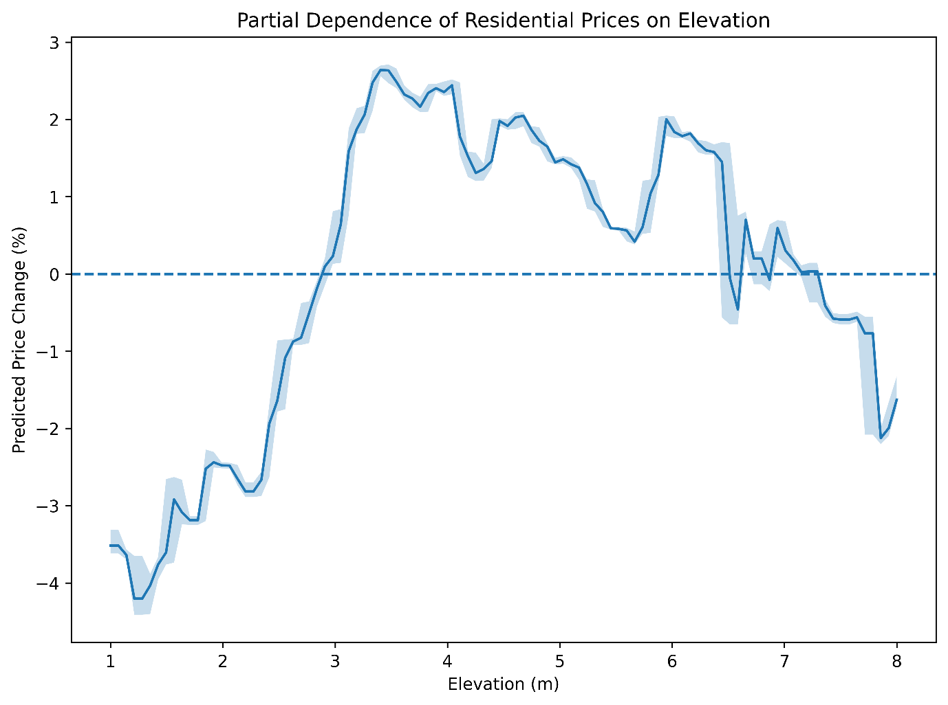
Figure 2: Partial Dependence of Residential Prices of Elevation
Note: The y-axis shows the marginal percent change in price, calculated by exponentiating the log-price partial dependence output $e^{β}-1$

Figure 2 presents the partial dependence of residential prices on elevation, expressed as percentage deviations from the sample mean.
The relationship is strongly nonlinear. Properties at very low elevations (≈1–2m above sea level) experience substantial valuation discounts of approximately 3.5–4.2%. This discount attenuates sharply between 2m and 3.2m, where predicted price effects increase by nearly five percentage points, transitioning from negative to positive territory.
Beyond approximately 3m elevation, the pricing function enters a premium regime, peaking around 3.5–4m with valuation gains of roughly 2.5%. However, this premium diminishes gradually between 4m and 6m, suggesting decreasing marginal valuation of additional vertical safety. At elevations above approximately 6.5m, the relationship reverses, with predicted price effects declining and reaching approximately –2% at the upper bound of the sample (≈8m). Confidence intervals widen in this upper range, reflecting thinner data support.
These findings indicate the presence of an elevation threshold in market capitalization behavior. The steep repricing between 2m and 3m suggests that buyers internalize nonlinear flood exposure risk rather than responding proportionally to incremental changes in elevation. Such curvature would be systematically underestimated in a linear hedonic specification.

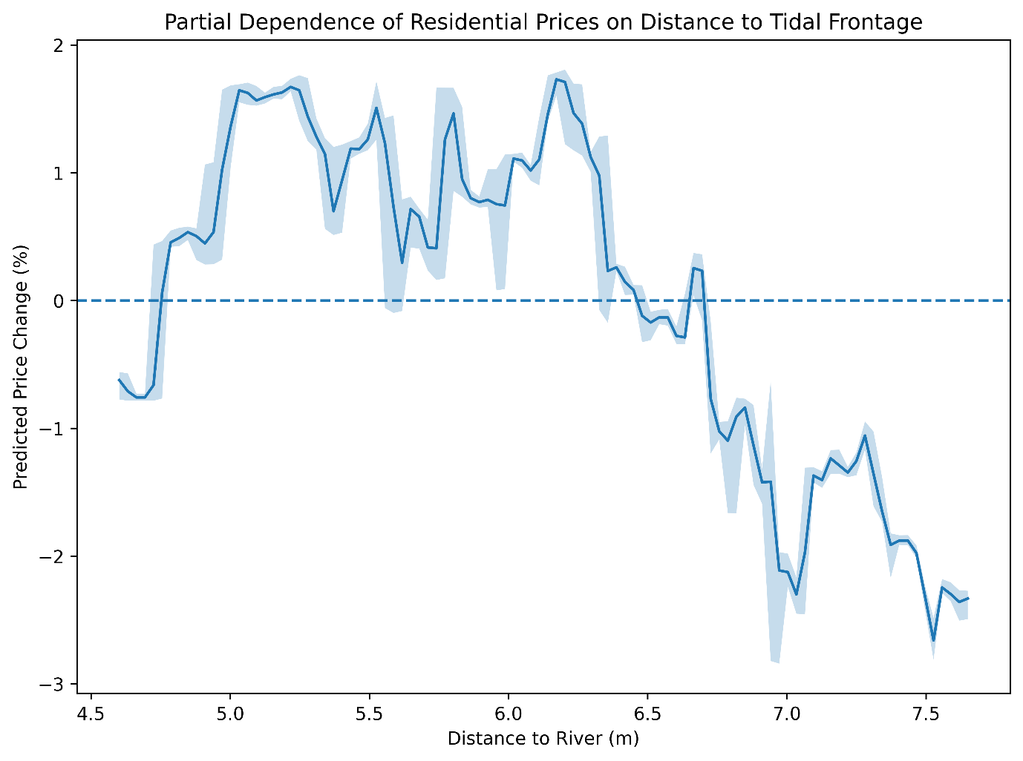
Figure 3: Partial Dependence of Residential Prices on Distance to Tidal Frontage

Figure 3 illustrates the partial dependence of predicted prices on distance to tidal frontage (log-transformed distance). The relationship exhibits clear non-monotonicity.
At shorter distances (left side of the distribution), the effect is slightly negative (approximately –0.7%), suggesting localized flood exposure or insurance-related pricing concerns in immediate proximity zones. However, as distance increases into the mid-range (approximately 5.0–6.2 in log scale), predicted price effects become positive, reaching premiums of approximately 1.5–1.8%. This segment likely reflects amenity-driven valuation, where proximity to waterfront landscapes enhances housing desirability.
Beyond approximately 6.3–6.5 (log scale), the pricing effect declines steadily, crossing into negative territory and reaching discounts of approximately –2.5% at the far end of the distribution. This decline suggests diminishing amenity value combined with increasing spatial separation from high-demand waterfront corridors.
Taken together, the curve reveals a spatial trade-off between waterfront amenity and hydrological exposure. The market does not price river proximity linearly; instead, it capitalizes an interior optimal distance where amenity value dominates risk perception.

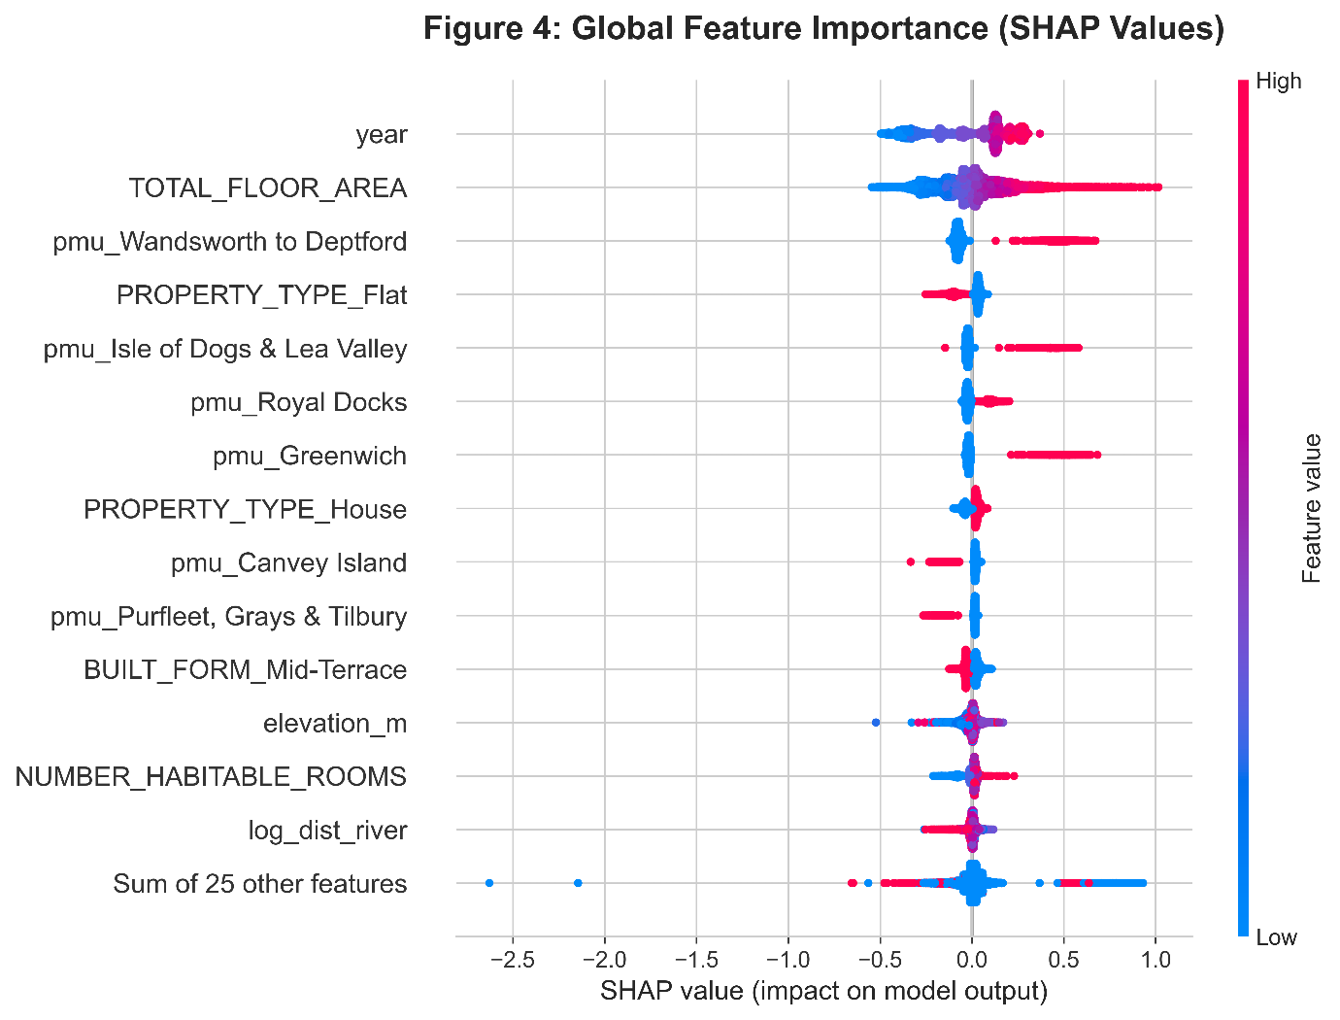

Figure 4 reports SHAP (SHapley Additive exPlanations) values, ranking global feature importance based on contribution to model output.
The most influential predictors include:
- Year (temporal market cycle effects)
- Total floor area
- Policy Management Unit (PMU) indicators
- Property type
- Elevation
- Distance to river
The prominence of PMU classifications (e.g., Wandsworth to Deptford, Isle of Dogs & Lea Valley, Royal Docks, Greenwich) indicates that regulatory geography materially influences predicted valuations. This supports the hypothesis that spatial climate governance frameworks are capitalized into housing prices.
Elevation and distance to river appear mid-ranking but exhibit wide dispersion in SHAP values, indicating heterogeneous effects across observations. Importantly, the color gradients reveal interaction effects: high elevation values (red points) are generally associated with positive SHAP contributions, whereas low elevation values (blue points) tend to reduce predicted prices. Similar heterogeneity appears for river distance, confirming the nonlinear PDP patterns.
The dispersion of SHAP values around zero for several PMU indicators further suggests localized heterogeneity rather than uniform zone-wide pricing effects. This reinforces the value of machine learning models capable of capturing interaction terms and nonlinear responses.

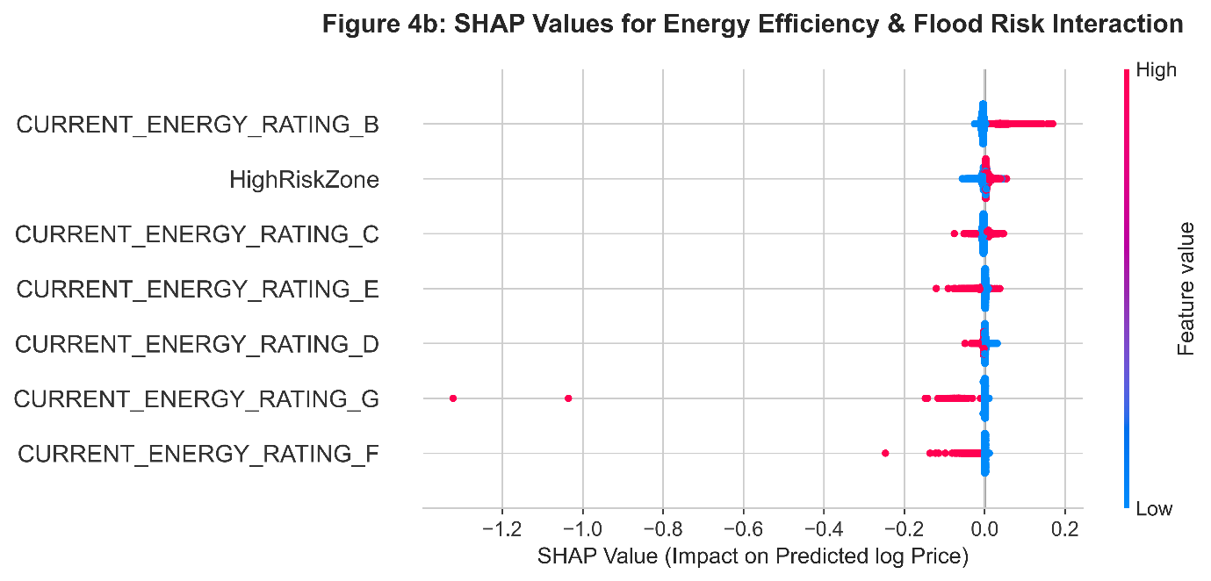

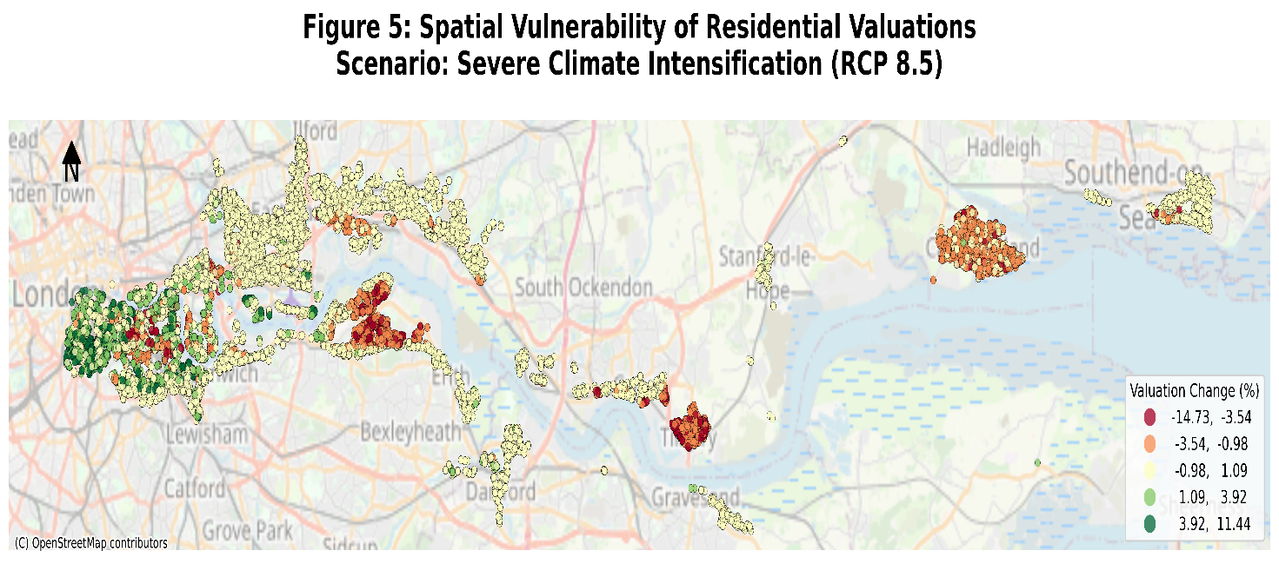

Figure 5 reveals significant spatial non-linearity in how climate-induced physical risks are capitalized into property valuations. While the stress-test applies a consistent intensification factor across the study area, the resulting valuation impact (ranging from -14.73% to +11.44%) is highly localized.
- Vulnerability Hotspots: The dark red clusters (<-3.54%) are concentrated in low-lying riparian corridors and estuarine zones (e.g., Tilbury, Gravesend, and Canvey Island). This suggests that the model identifies a compounding effect where proximity to water sources acts as a primary risk multiplier for lower-elevation assets.
- Localized Resilience: Conversely, the green nodes (>3.92%) represent "islands of resilience." These are properties that, despite geographic proximity to risk zones, possess structural attributes, such as superior energy efficiency ratings or larger habitable floor areas, that the market appears to price as a defensive hedge against physical shocks.

Table 3: Observed vs Projected Climate Risk Capitalization
Measure | Estimated Effect (%) | Meaning
Observed High-Risk Zone Discount (SHAP-based) | -0.63 | Average current market pricing of high flood risk
Low Elevation Discount (1–2m) | -4.2 | Nonlinear capitalization of extreme physical exposure
Peak Elevation Premium (~3.5m) | +2.5 | Peak Elevation Premium (~3.5m)
Maximum Projected Loss (RCP 8.5) | -14.7 | Stress-test valuation under severe climate intensification
Stress Amplification Ratio | 23.3x | Projected loss relative to current observed pricing

Table 2 contrasts observed market capitalization of flood exposure with nonlinear physical risk effects and projected stress losses under severe climate scenarios. The estimates reveal a pronounced divergence between current pricing signals and extreme climate risk projections.
1. Observed High-Risk Zone Discount (SHAP-based): –0.63%
This estimate reflects the average marginal contribution of the HighRiskZone indicator to predicted log property prices, converted into percentage terms using:

$$Observed HighRisk Discount= \left(e^{\overset{⃑}{∅HighRisk}}-1\right) ×100$$
Where:
- $∅HighRisk$ denotes the SHAP contribution of the HighRiskZone indicator
- The bar denotes the mean across properties in high-risk zones.
- The mean SHAP contribution of the HighRiskZone indicator is converted from log-price units to percentage price impact using the exponential transformation.
The magnitude of –0.63% suggests that properties located within high flood-risk zones experience a modest valuation discount relative to otherwise comparable properties.
- The market appears to internalize flood exposure.
- However, the economic magnitude is small.
- This indicates partial but limited capitalization of regulatory flood classification.
In monetary terms, for a £500,000 property, this implies an average discount of approximately £3,150 - economically noticeable but not substantial.

2. Low Elevation Discount (1–2m): –4.2%
The partial dependence results indicate that properties located at very low elevations (1–2 metres above sea level) experience an average predicted price discount of approximately –4.2%.
- This effect is nearly seven times larger than the binary high-risk zone discount
- Elevation captures a continuous physical exposure gradient.
- The market appears to penalize extreme physical vulnerability more strongly than administrative flood classifications.
This finding suggests that buyers respond more to physical geography than to regulatory labels.
3. Peak Elevation Premium (~3.5m): +2.5%
The partial dependence plot reveals a nonlinear structure in which property values increase with elevation up to approximately 3.5 metres, generating a premium of roughly +2.5%.
- There exists an optimal elevation band where perceived safety is capitalized
- Beyond this threshold, premiums plateau or decline.
- This reflects nonlinear hedonic valuation rather than a monotonic relationship.
This reinforces the importance of modeling climate risk using flexible machine learning approaches rather than linear specifications.

4. Maximum Projected Loss under Severe Climate Scenario (RCP 8.5): –14.7%
The stress-testing framework projects valuation losses reaching –14.7% under a severe intensification scenario consistent with high-emissions climate trajectories.
- This magnitude is substantially larger than current observed pricing.
- It reflects forward-looking physical intensification rather than historical exposure.
- The projected losses are economically material and systemically significant.
For a £500,000 property, this implies a potential loss exceeding £73,500.
5. Stress Amplification Ratio: 23.3×
The stress amplification ratio compares projected severe losses (14.7%) to the observed high-risk discount (0.63%):
Stress Amplification Ration = $\frac{Maximum Projected Loss (RCP 8.5)}{Observed HighRisk Zone Discount }= \frac{14.7}{0.63}≈23.3$
- Severe climate risk implies losses more than twenty times larger than currently priced discounts.
- This suggests substantial underpricing of extreme tail climate risk.
- The housing market appears to internalize incremental exposure but not catastrophic intensification.

